Names: Bailey Scott and Colin Quinn

**Week 9: Cardiovascular System**

**Part 1: Connect videos**

**Please take notes on the videos from Connect for your reference:**

**A. ‘blood: blood typing,”**

* **Blood types are determined by the antigens that are present on the surface of red blood cells (RBCs, also known as erythrocytes).**
* **Red blood cell membranes contain glycoproteins and glycolipids that determine your ABO blood type and proteins that determine your Rh (+/-) blood type.**
  + **ABO blood type is determined by the presence of A, B, both (AB), or neither (O) of the A or B antigens.**
  + **Rh blood type is determined by the presence of (+) or lack of (-) the D antigen.**
* **The blood plasma may also contain antibodies, depending on the ABO and Rh blood types.**
  + **If you have blood type A, you will have anti-B antibodies.**
  + **If you have blood type B, you will have anti-A antibodies.**
  + **If you have blood type O, you will have both anti-A antibodies and anti-B antibodies.**
  + **If you have blood type AB, you will NOT have any anti-A nor anti-B antibodies.**
  + **No one has anti-D (Rh) antibodies unless they are Rh- AND have been previously exposed to Rh+ blood.**
* **Blood can only be donated from a person with a specific ABO antigen to a person without antibodies for that antigen. Otherwise, agglutination (clumping) will occur.**
  + **Type A cannot donate to Type B or Type O because they both have anti-A antibodies.**
  + **Type B cannot donate to Type A or Type O because they both have anti-B antibodies.**
  + **Type AB cannot donate to Type A because they have anti-B antibodies or Type B because they have anti-A antibodies.**
  + **Type O can potentially donate to everyone because their blood has no antigen to attack. However, Type O should first have its own anti-A and anti-B antibodies removed.**
  + **Rh+ blood should not be transfused to an Rh- person; however, Rh- blood can be donated to an Rh+ person.**

**B. “blood:hematocrit”**

* **Hematocrit (HCT) is the percentage of erythrocytes, or red blood cells (RBCs), in a whole blood sample.**
* **Hematocrit (HCT) is determined by separating the formed elements from the plasma and measuring the packed red blood cell volume.**
* **Normal hematocrit varies depending on many factors, but generally accepted ranges are:**
  + **Adult males: 42**
  + **–52%**
  + **Adult females: 37**
  + **–47%**
* **An abnormally elevated hematocrit can occur for several reasons, such as being at a high altitude, having an elevated testosterone level, with certain diseases, and if the person is "blood doping."**
* **Blood doping refers to any of several methods used to increase the blood oxygen-carrying capacity.**

**C. “blood: hemoglobin content”**

* **Red blood cells (RBCs) are about one-third hemoglobin. Hemoglobin is the main protein that carries oxygen and some carbon dioxide in the blood.**
* **Healthy hemoglobin content in the blood varies with age, sex, and other factors. Generally, the values below are considered the normal range.**
  + **Male: 14**
  + **–18**
  + **g Hb/100 mL**
  + **Female: 12**
  + **–16**
  + **g Hb/100 mL**
* **The hemoglobin content of blood is one measure of the oxygen-carrying capacity of the blood.**
* **An abnormally elevated hemoglobin content will occur if someone is "blood doping."**
* **Blood doping refers to any of several methods used to increase the blood oxygen-carrying capacity.**

**D.“differential white blood cell count”**

* **A differential white blood cell count (DIFF) determines the percentage of the various types of white blood cells (WBCs), also known as leukocytes, in a blood sample.**
* **A complete blood count (CBC) with DIFF is often run in the lab on a machine that counts with an algorithm to match cells. However, many clinicians request a manual count from a trained lab tech's perspective when highly accurate counts are necessary or if cells are expected to be irregular, such as in leukemias.  
    
  It is important to learn this technique, as the values that come back from this test are important to clinical diagnosis and evaluation of how/what the immune system is doing in the patient.**
* **Leukocytes, or white blood cells (WBCs), can be divided into two subgroups depending on whether or not their cytoplasm contains granules that are visible using a brightfield microscope.**

**E. “cardiovascular physiology: pulse rate”**

* Blood pressure is the force of blood against the inside of blood vessel walls.
* Blood will only move down its pressure gradient, from high to low pressure. Therefore, adequate blood pressure must be maintained.
* Blood pressure can be influenced primarily by: cardiac output, peripheral resistance, and blood volume. Body position, exercise, and other factors may affect some of these variables.
* Systolic pressure is the maximum pressure in an artery during ventricular contraction.
* Diastolic pressure is the minimum pressure in an artery during ventricular relaxation.

**Part 2: Heart Anatomy—please refer to either the textbook, chapter 5 (sections indicated), chapter 6 section 1, and use the following websites to view sheep heart dissection photos as indicated.**  [**https://www.biologycorner.com/anatomy/circulatory/heart/heart_dissection.html**](https://www.biologycorner.com/anatomy/circulatory/heart/heart_dissection.html)

[**https://courses.lumenlearning.com/bio2labs/chapter/reading-fetal-pig-dissection/**](https://courses.lumenlearning.com/bio2labs/chapter/reading-fetal-pig-dissection/)

Section 5.1 & 5.2 Introduction to the Cardiovascular system (p. 90-92)

1. What are the 3 functions of the cardiovascular system (p. 90)?

Transport of oxygen to the cells, protection of cells in the immune system, and regulation of the body’s homeostasis.

2. What is the main role of veins? What are venules?

Small veins that drain blood from the capillaries to form a vein.

3. Draw and label the parts of a vein in cross section (Figure 5.2).



4. What is the main role of arteries? What are arterioles?

A blood vessel that transports blood away from the heart. Arterioles are smaller arteries that are barely visible to the naked eye, and is comprised of smooth muscle tissue.

5. Draw and label the parts of an artery in cross section (Figure 5.2).



6. What is the role of a capillary ? What are capillary beds? What are precapillary sphincters?

Arterioles branch into capillaries, which are the smallest blood vessels. Capillary beds are networks of many capillaries. Precapillary sphincters are small rings of muscle that control the flow of blood through a capillary bed.

7. What is an arteriovenous (AV) shunt? When will an AV shunt be utilized?

An abnormal pathway that connects an artery directly to a vein.

Section 5.3 The Heart (p. 93-

1. What are the left and right sides of the heart divided by?

A muscular wall that prevents mixing of blood.

2. How many chambers does the heart have?

Four, two upper and two lower.

3. What keeps blood flowing in one direction inside the heart?

The muscular wall that splits the heart into left and right.

4. Where does each side of the heart send blood?

Left: Into the body

Right: The lungs to get oxygenated

5. Examine a sheep heart [here](https://www.biologycorner.com/anatomy/circulatory/heart/heart_dissection.html)). Draw the external anatomy. Identify and label the following: right atrium, right ventricle, pulmonary trunk, left atrium, apex, and left ventricle. Compare this to Figure 5.3



6. Now using the [link](https://www.biologycorner.com/anatomy/circulatory/heart/heart_dissection.html)), examine the internal anatomy. Draw what you see. Identify and label the following: right atrium, right ventricle, septum, pulmonary semilunar valve, chordae tendineae, aortic semilunar valve, left atrium, left ventricle, tricuspid valve, bicuspid valve, apex and aorta. Use Figure 5.4 in helping you to identify these, but base your drawing on the link.



7. Name the four valves of the heart and describe where they are located.

Aortic Semilunar Valve: Between left ventricle and aorta

Tricuspid Valve: Between right atrium and right ventricle

Bicuspid Valve: Between left atrium and left ventricle

Pulmonary Semilunar Valve: Between left ventricle and pulmonary artery

8. What does heart tissue look like? Draw it here, and identify the intercalated disks.



9. What is the role of intercalated disks and the gap junctions used between cardiac cells?

Intercalated disks tightly join fibers, and gap junctions aid in simultaneous contractions of cardiac fibers.

10. To demonstrate that O2 poor blood is kept separate from O2 rich blood, trace the path of blood from the body to the right side of the heart, all the way through the aorta. Make a line diagram with arrows between each entity.

Body -> s. and i. vena cava on rt. Side of heart -> Right atrium -> right ventricle -> Pulmonary capillaries -> Pulmonary veins -> left atriums -> left ventricle -> aorta ________________________

_________________________________________________________________________

_________________________________________________________________________

_________________________________________________________________________

Which side of the heart (right or left) pumps O2-poor blood?

Right side

Cardiovascular Pathways (and context of Cardiovascular system of a fetal pig)

Note: The following 3 images (labeled Figure 32 & 44 & 35) come from the Lumenlearning website of free course material<https://courses.lumenlearning.com/bio2labs/chapter/reading-fetal-pig-dissection/>. Please read Section 5.5 of your textbook

Notice the thin pericardial membrane surrounding the heart in Figure 32. This protective sac contains a small amount of lubricating fluid to protect the heart and cushion its movements. A portion of the relatively large thymus sits on the outside of the pericardial membrane and partially obscures the heart from view.

Now examine the cardiovascular system of the pig as a whole, focusing not just on the heart but now on the blood vessels from the following image:

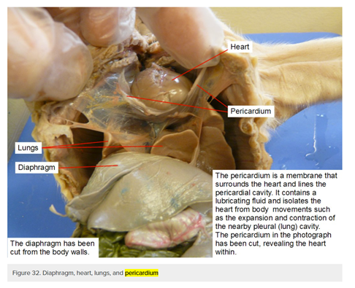

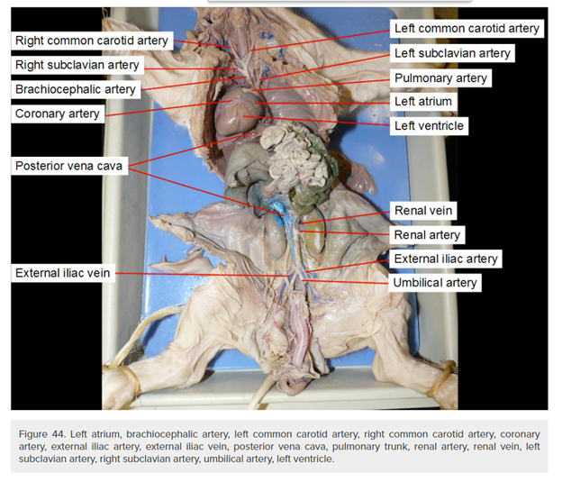

For the following 2 questions, consider figures 32-39 and 43 of the website link [here](https://courses.lumenlearning.com/bio2labs/chapter/reading-fetal-pig-dissection/):

1. To help you connect with this material, sketch the heart and surrounding area while the heart is in context. Label the pericardium, thymus, and lung.



2. Now sketch what lies beneath the heart and label the larynx, trachea, esophagus, bronchus, pulmonary arteries and veins, lungs and diaphragm and faintly indicate with dashed lines where the heart fits into this image.



3. Using the image on the following page (Figure 35) as well as your textbook section 5.5, Figure 5.11,

A. I. Sketch the pathway of blood flow leaving the heart to go to the head.



II. Sketch the pathway of bloodflow leaving the head, going to the heart. Consider Image 35 on the next page for a non-cartoon sketch of this.



B. Sketch the pathway of blood flow leaving the heart to go to the kidney, using the image as well as the textbook page. II. Sketch the pathway of bloodflow leaving the kidney, going to the heart.



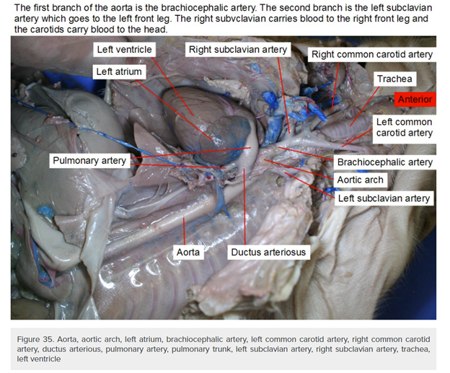

4. Use Section 5.5 of your textbook to fill in the following table for the Systemic Circuit.

|  |  |  |
| --- | --- | --- |
| Body Part | Artery that directly supplies blood | First Vein that directly drains this area |
| Heart | Subclavian Artery | Subclavian Vein |
| Head | Common Carotid Artery | Jugular Vein |
| Arms | Radial Artery | Brachial Veins |
| Kidney | Renal Artery | Renal Vein |
| Legs | Femoral Artery | Femoral Vein |
| Intestines | Inferior Mesenteric Artery | Mesenteric Vein |

5.4 Heartbeat and Blood Pressure

1. During a heartbeat, first the Atria contract and then the Ventricles contract.

Link: http://www.uhnj.org/cardiology/yourheartandheartdisease/index.htm#:~:text=The%20heart%20contracts%20in%20two,blood%20out%20of%20the%20heart.

2. What is it called when a heart chamber contracts?

Systole

Link: https://www.medicalnewstoday.com/articles/321447#:~:text=The%20terms%20diastole%20and%20systole,heart%20muscles%20relax%20and%20contract.&text=During%20this%20cycle%2C%20the%20period,of%20contraction%20is%20called%20systole.

3. What is it called when a heart chamber relaxes?

Diastole

Link: https://www.medicalnewstoday.com/articles/321447#:~:text=The%20terms%20diastole%20and%20systole,heart%20muscles%20relax%20and%20contract.&text=During%20this%20cycle%2C%20the%20period,of%20contraction%20is%20called%20systole.

4. Read the article<https://www.healthline.com/health/athlete-heart-rate>.

A. What is a normal range for one’s resting heart rate?

60-80 BPM

B. What is an athlete’s resting heart rate?

30-40 BPM

C. What are some influences on resting heart rate?

Age, fitness level, amount of physical activity, air temperature, emotion, medication

D. For the following exercise, you will be taking your pulse manually as described in the healthline article. You can alternatively use a biometric device on your watch if you have one.

Complete the following table for you and your partner(s) if applicable. These numbers represent the resting heart rate.

|  |  |  |
| --- | --- | --- |
| Your Names: | Pulse Reading | Is this in range for your activity level (athlete/non athlete)? |
| Bailey Scott | 72 | Yes, non-athlete |
| Colin Quinn | 66 | Yes, non-athlete |
|  |  |  |

6. Jump as if you are jumping rope 80 times or run in place. Measure your pulse. Fill in the following table with your information. This simulates the after exercise heart rate.

|  |  |  |
| --- | --- | --- |
| Your Names: | Pulse Reading | What is your target heart rate |
| Bailey Scott | 126 | 100-140 |
| Colin Quinn | 122 |  |
|  |  |  |

7. Calculate out your maximum heart rate.

Bailey: 220-19=201

Colin: 220 - 22 = 198

8. Calculate your target training zone.

Bailey: 201*.5=100.5 or 201*.7=140

Colin: 198*.5 = 99 through 198*.7 = 138.6

Section 6.1 The Blood and Blood Flow

To complete this section, please look at section 6.1 of your textbook.

1. What are the functions of blood in the human body?

Transport, defense, regulation

2. What are the 3 types of formed elements and what are their roles?

Red blood cells: transports O2 and helps transport CO2

White blood cells: active in specific immunity, become large phagocyte, phagocytizes, active in allergies and worm infections, and releases histamines

Platelets: Aids blood clotting

3. What is plasma made up of/what percentage do each of the 3 categories of plasma contents make up?

91% water

7% Proteins

2% Ions/nutrients, waste products, gases, hormones, and vitamins

4. What are the percentages of plasma in blood? Of formed elements?

55% Plasma

45% Formed elements

5. Considering our previous discussions of blood typing, A) Draw the expected results of an antibody test for two differing blood types, B) define the blood type, and C) give the logic for your answer.

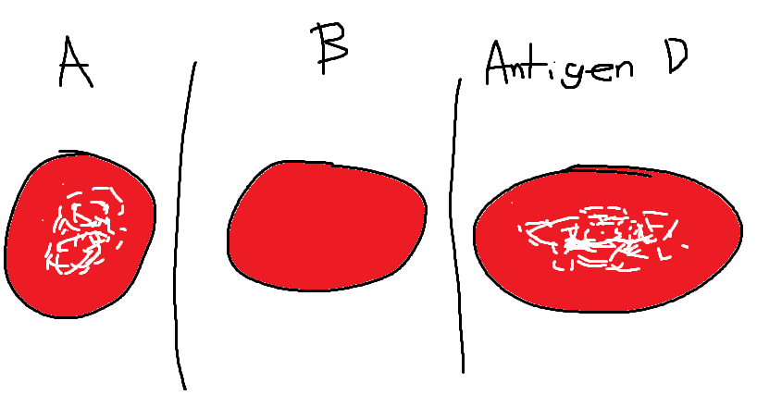

This give the blood type A+, because the clumping happens in blood sample A and antigen D.

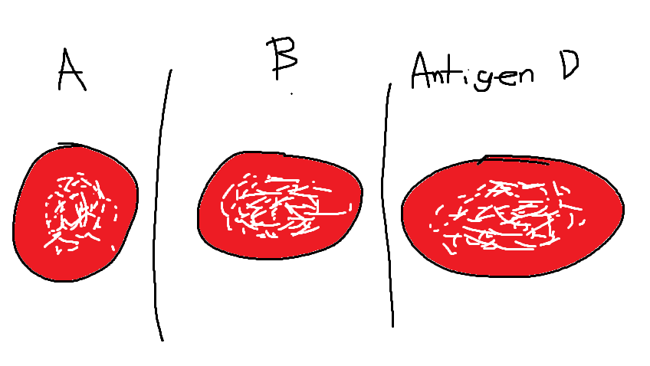

This gives the blood type AB+, because the clumping is in all samples.

Questions for Review (no response is needed)

1. What two arteries carry blood away from the heart?

2. What two veins carries the blood returning to the heart?

3. What connects arterioles to the venules?

4. What is the name of the circuit that the right side of the heart will pump blood into?

5. What is the name of the circuit that the left side of the heart will pump blood through the whole body?

6. Does the pulmonary artery in adults carry O2 rich or O2 poor blood?

7. Which type of blood shows no reaction to anti-A and anti-B serum (antibodies) in ABO blood typing studies?